Long Runs for High Schoolers
Go long in summer to race your best in the fall
By
Marc Bloom

John McGowan, one of the nation's leading high school distance runners this past school year, ran weekly long runs of 11 to 13 miles the summer of 2010 and into the fall to help build his aerobic base for cross country. Even though most of his fall races were 5,000m, he knew the many benefits of going long. 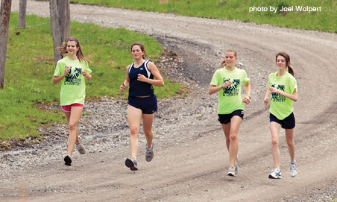 "The long run is the key component of base building," says McGowan, recently graduated from Sidwell Friends, a Quaker school in Washington, D.C. "Long runs help me perform better in the latter stages of a cross country race. You feel a gradual fatigue similar to the fatigue of cross country. It's important to get used to that feeling before the fall season." This adaptation to fatigue enabled McGowan to place 16th last December in the Foot Locker Cross Country Championships. With his abundant fitness reserves, McGowan, who is going on to Yale, went on to excel in track as well, running 4:11 for 1600m. Many high school runners, however, barely touch long runs during base work. For some, the summer heat may seem too much to bear. Others may believe that 5 or 6 miles is long enough for 5K racing. They, and perhaps their coaches, may not realize that running longer–from 8 to 12 miles–produces a range of gains in building running prowess. GET AN OXYGEN AND ENERGY BOOST For high school cross country runners, a key benefit of long runs is that they boost the number and efficiency of your capillaries (tiny blood vessels that supply working muscles with oxygen) and mitochondria (think of them as your muscle cells' power plants). As a result of this positive adaptation, you can maintain a strong pace for longer and will be fresher than the runners around you when it's time for your finishing kick. McGowan says that his long runs were about 20 percent of his weekly mileage, a formula used by many coaches, including Steve McChesney of Newton South High, a Massachusetts state power. At Newton South, boys with at least two years of training behind them do long runs of 9 to 12 miles; for girls with comparable experience, the distance is 7.5 to 9 miles. Similarly, in the Salt Lake City area, the older athletes on the Davis High cross country squad, ranked 12th in the country last fall, do weekly 10-to 12-milers in the summer, says Davis coach Corbin Talley. Freshmen and other new runners start modestly and build up. While doing initial long runs at a slowish pace is fine, don't consider the effort pure easy running as you progress. Giving his athletes some leeway, McChesney says, "I tell them the pace should be fast enough to be interesting and comfortable enough to engage in conversation."

